PRAYER SHEET
Prayer Sheet Date: ________
- Recommended: Bible, Moms in Prayer Ministry Booklet
- Start and end on time.

Praise—Praising God for who He is, His attributes, His name or His character
(Please no answers to prayer or prayer requests during this time.)
Attribute:
Definition:
Scripture(s):
Confession—Silently confessing your sins to the God who forgives.
If we confess our sins, He is faithful and righteous to forgive us our sins and to cleanse us from all unrighteousness. 1 John 1:9 (NASB)
Thanksgiving—Thanking God for what He has done. Please no prayer requests during this time.
In everything give thanks; for this is God’s will for you in Christ Jesus. 1 Thessalonians 5:18 (NASB)
Intercession—Coming to God in prayer on behalf of others. Form groups of two or three.
Our Own Children—Each mom chooses one child. First pray the scripture then pray a specific request.

Scripture:

Specific Request:
1st Mom’s Child:
2nd Mom’s Child:
3rd Mom’s Child:

Teachers/Staff
Open _____________’s eyes and turn him/her from darkness to light, and from the power of Satan to God, so that he/she may receive forgiveness of sins and a place among those who are sanctified by faith in Jesus. (From Acts 26:18)

Other scripture:

Specific Request:

School Concerns—Revival and spiritual awakening on the school campus

Other concerns:

Moms in Prayer Concerns—Every school covered in prayer; protect the ministry keeping it untarnished and pure

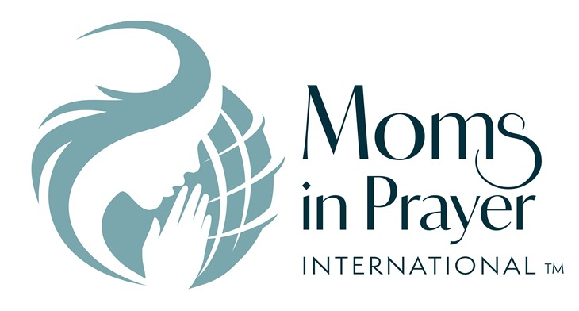

Remember, what is prayed in the group, stays in the group!

